“个人学术理论”.

One, in the Dark Age, there was the history of Galileo and Inquisition: a story about the killing of pure science. Why is today still having the Dark Age practice in China, banning the pure science in the name of being “个人学术理论”?

Two, what is “个人学术理论”? What we are talking about is a part of the Western knowledge, although not the mainstream.

First, for physics, the Super Unified Theory (the 个人学术理论); it is:
In the World HEP (High Energy Physics) archives, see http://inspirehep.net/search?p=find+a+gong,+jeh+tween

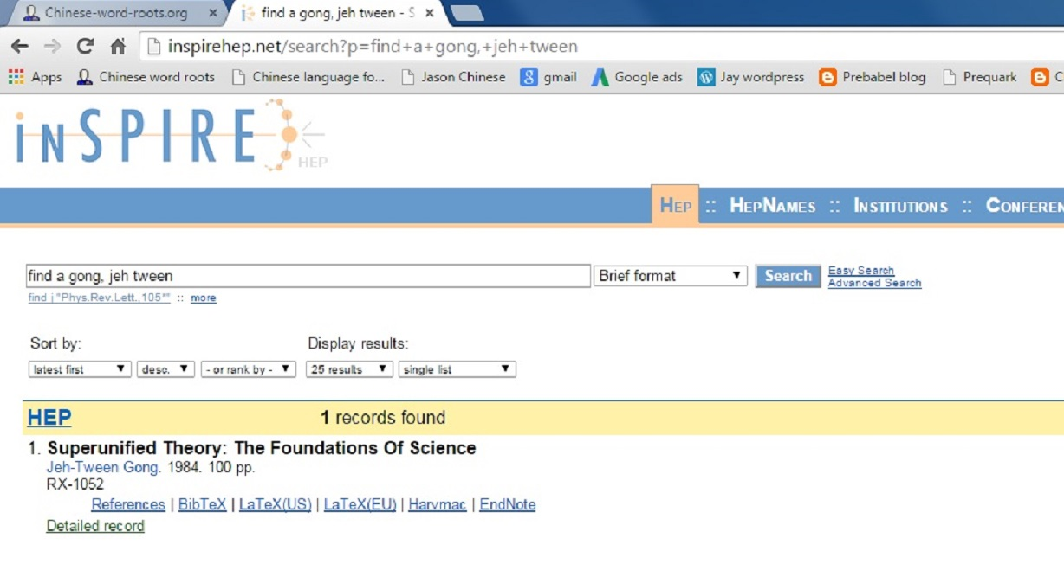
Inspire is the world HEP (High Energy Physics) information system (archives)

This 个人学术理论 is collected by many world best university-libraries, see http://www.worldcat.org/title/super-unified-theory-the-foundations-of-science/oclc/11223955&referer=brief_results

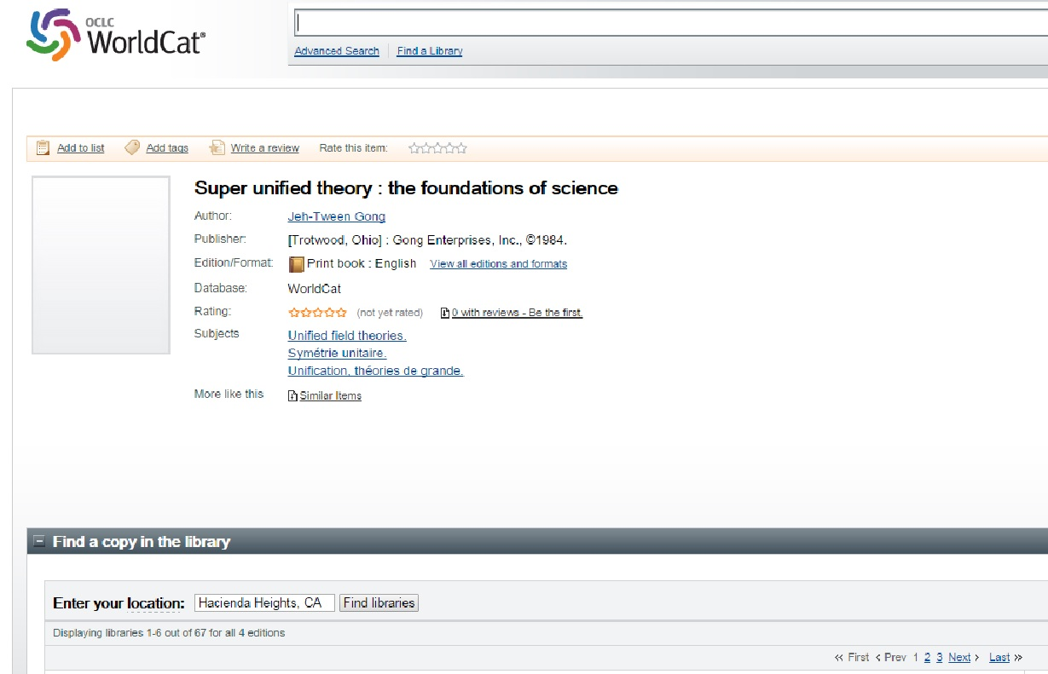

The WorldCat is the world largest Library-Catalog

This 个人学术理论 is listed as Google book, see https://books.google.com/books?id=rieCAAAAIAAJ&q=inauthor:%22Jeh-Tween+Gong%22&dq=inauthor:%22Jeh-Tween+Gong%22&hl=en&sa=X&ei=JIHyT-3sO8mA2wW90bz3AQ&ved=0CDkQ6AEwAA

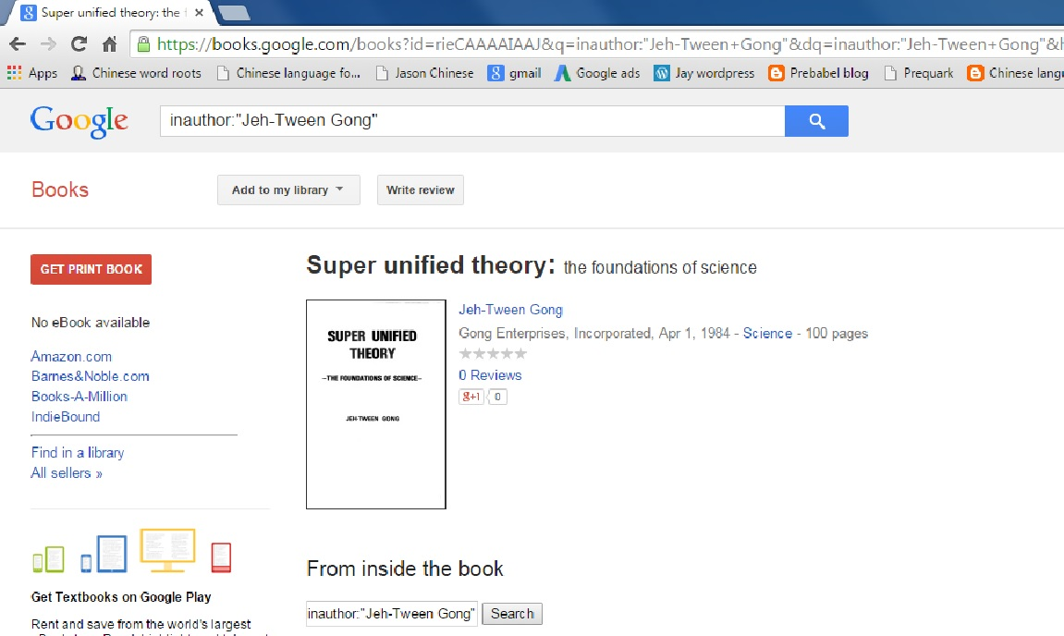

This 个人学术理论 is carried by the world’s largest book store, Amazon.
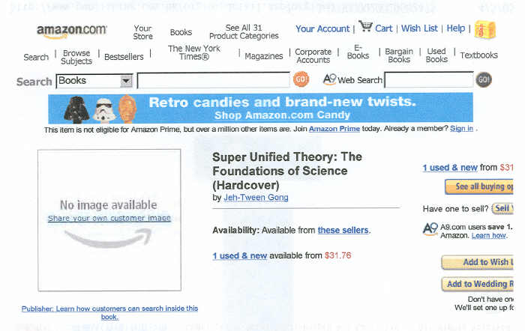

This 个人学术理论 (the Prequark) is also archived by Inspire (the world HEP information system), see http://inspirehep.net/search?p=find+ea+gong,+j+t

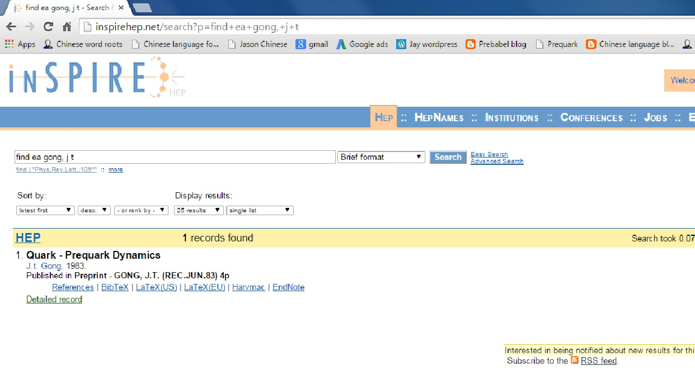

When Google the keyword Prequark (a genuine physics model), this个人学术理论 is always on the first of the first page, among a few thousand results.

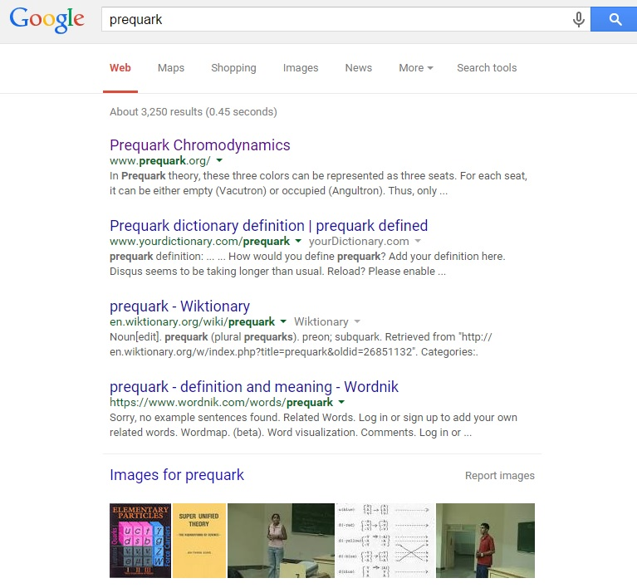

The other part of this 个人学术理论 is about the linguistics, and its book:
First, it is collected by many world’s top university-libraries, see http://www.worldcat.org/title/linguistics-manifesto-universal-language-the-super-unified-linguistic-theory/oclc/688487196&referer=brief_results

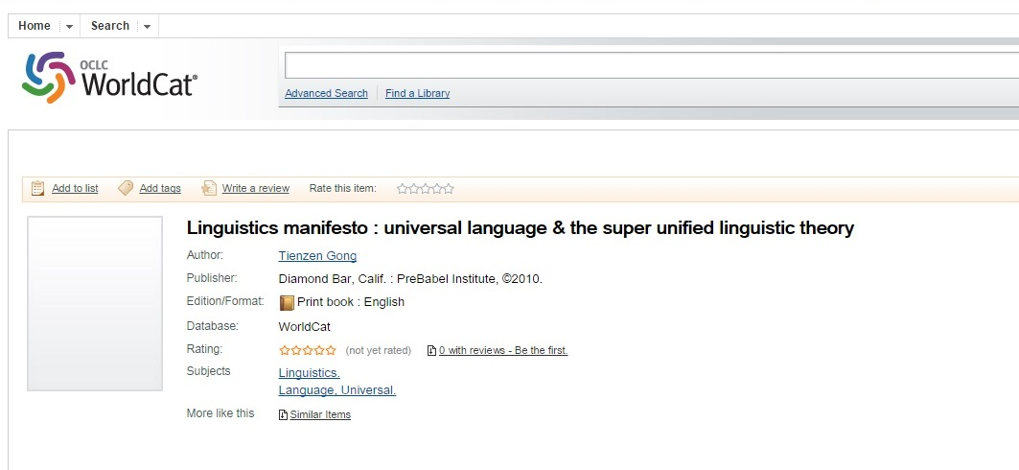

And 个人学术理论 is also listed in Google book, see https://books.google.com/books?id=Uh8EtwAACAAJ&dq=inauthor:%22Jeh-Tween+Gong%22&hl=en&sa=X&ei=JIHyT-3sO8mA2wW90bz3AQ&ved=0CE4Q6AEwBA

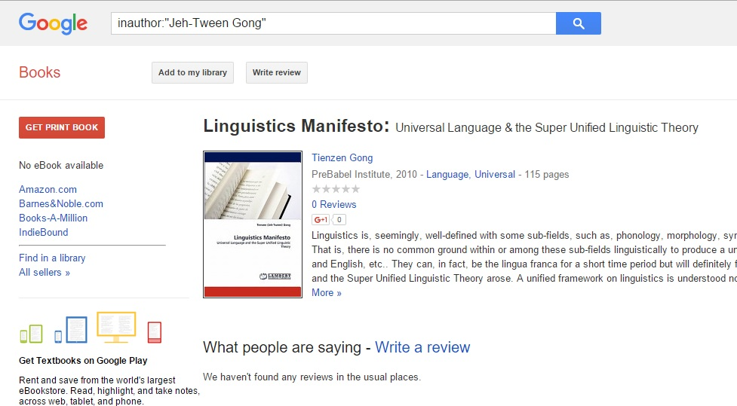

And here is a comment from the Librarian of Cornell University.
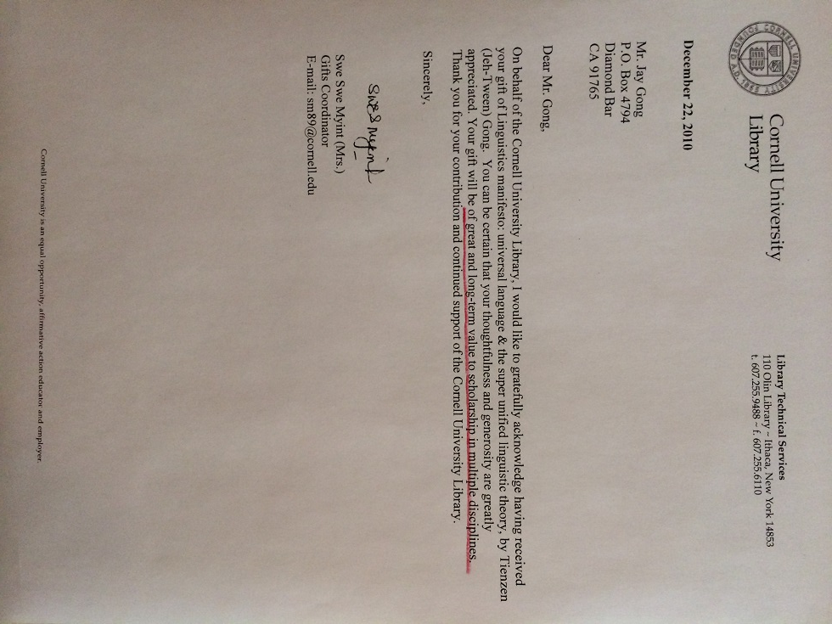
This 个人学术理论 is published by a German academic publisher (LAP LAMBERT Academic Publishing) and carried by the world’s largest bookstore, Amazon, see http://www.amazon.com/Linguistics-Manifesto-Universal-Language-Linguistic/dp/3838397223/ref=sr_1_3?ie=UTF8&s=books&qid=1292180552&sr=8-3
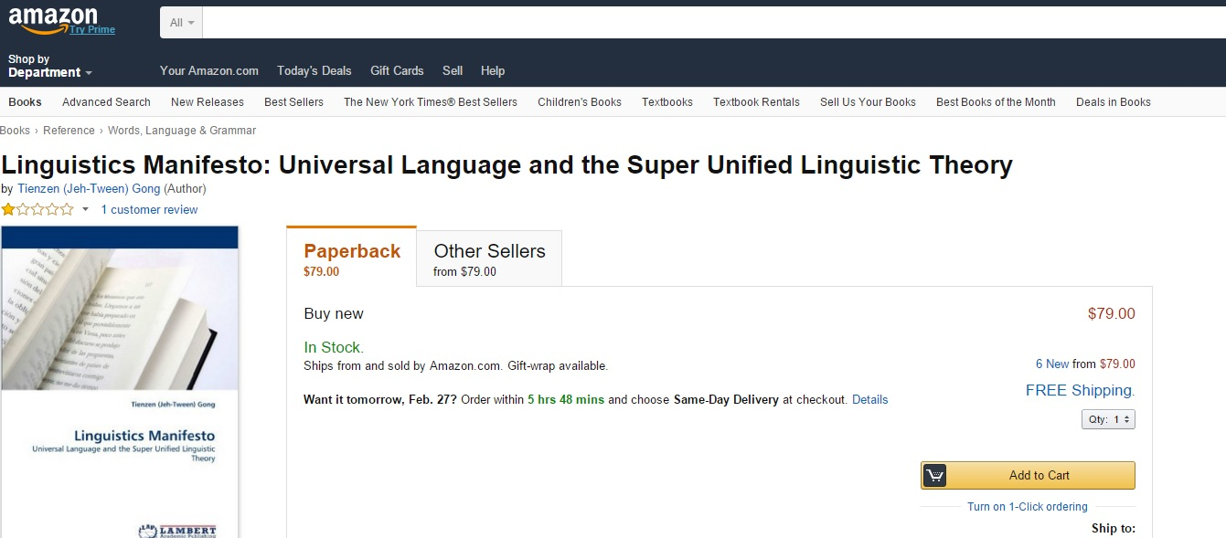

We are a very big part of the West knowledge.

